**Acknowledgement**

First of all I would like to thank Mr. Manish Gupta for giving me this opportunity

**Index**

|  |  |  |
| --- | --- | --- |
| **S.no** | **Content** | **Page no.** |
| 1. | What is a recommendation system | 3 |
| 2. | Why do we need a recommendation system | 3 |
| 3. | Types of recommendation system | 4 |
| 4. | Collaborative Filtering | 4 |
| 5. | Content based filtering | 5 |
| 6. | Hybrid based filtering | 6 |
| 7. | Tmdb-The movie database | 6 |
| 8. | Step- 1 Import the databse | 7 |
| 9. | Step-2 Data Exploration and cleaning | 8-10 |
| 10. | Step-3 Merge the 2 CSV files | 11 |
| 11. | Step-4 Working with the genres column | 11-14 |
| 12. | One hot encoding for multiple labels | 14 |
| 13. | Step-5 Working with the cast column | 14-16 |
| 14. | Step-6 Working with the directors column | 16-19 |
| 15. | Step-7 Working with keywords column | 19-22 |
| 16. | Step-8 Similarity Between the movies | 22-26 |
| 17. | Step-9 Score predictor(Final Step) | 29-33 |
| 18. | Conclusion | 34 |
| 19. | Bibliography | 35 |
|  |  |  |
|  |  |  |
|  |  |  |

**Recommendation System**

**What is a recommender system?**

A recommender system is a simple algorithm whose aim is to provide the most relevant information to a user by discovering patterns in a dataset. The algorithm rates the items and shows the user the items that they would rate highly. An example of recommendation in action is when you visit Amazon and you notice that some items are being recommended to you or when Netflix recommends certain movies to you. They are also used by Music streaming applications such as Spotify and Deezer to recommend music that you might like.

Here in this project I am going to build a project using collaborative and content based filtering i.e using hybrid filtering.

**Why Do We Need Recommender Systems?**

We now live in what some call the “era of abundance”. For any given product, there are sometimes thousands of options to choose from. Think of the examples above: streaming videos, social networking, online shopping; the list goes on. Recommender systems help to personalize a platform and help the user find something they like.

The easiest and simplest way to do this is to recommend the most popular items. However, to really enhance the user experience through personalized recommendations, we need dedicated recommender systems.

From a business standpoint, the more relevant products a user finds on the platform, the higher their engagement. This often results in increased revenue for the platform itself. Various sources say that as much as 35–40% of tech giants’ revenue comes from recommendations alone.

Now that we understand the importance of recommender systems, let’s have a look at types of recommendation systems, then build our own with open-sourced data!

## Types of Recommendation Systems

Recommendation systems can be broadly classified into 3 types —

1. Collaborative Filtering
2. Content-Based Filtering
3. Hybrid Recommendation Systems

### Collaborative Filtering

This filtering method is usually based on collecting and analyzing information on user’s behaviors, their activities or preferences, and predicting what they will like based on the similarity with other users. A key advantage of the collaborative filtering approach is that it does not rely on machine analyzable content and thus it is capable of accurately recommending complex items such as movies without requiring an “understanding” of the item itself.

Further, there are several types of collaborative filtering algorithms —

* **User-User Collaborative Filtering:** Try to search for lookalike customers and offer products based on what his/her lookalike has chosen.
* **Item-Item Collaborative Filtering:** It is very similar to the previous algorithm, but instead of finding a customer lookalike, we try finding item lookalike. Once we have an item lookalike matrix, we can easily recommend alike items to a customer who has purchased an item from the store.
* **Other algorithms:** There are other approaches like market basket analysis, which works by looking for combinations of items that occur together frequently in transactions.

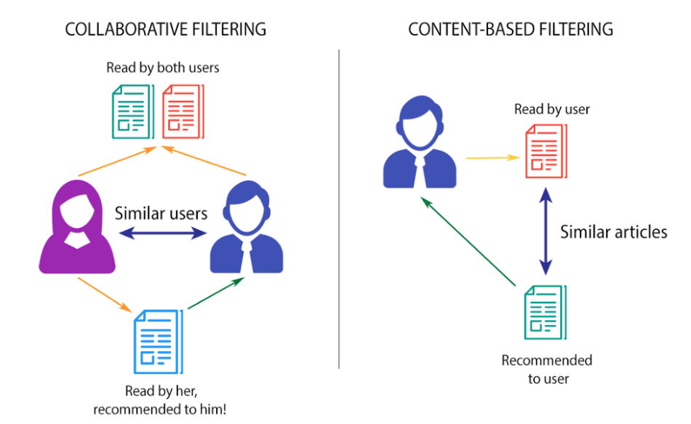

Fig. Above is an illustration of collaborative vs content based filtering

### Content-based filtering

These filtering methods are based on the description of an item and a profile of the user’s preferred choices. In a content-based recommendation system, keywords are used to describe the items, besides, a user profile is built to state the type of item this user likes. In other words, the algorithms try to recommend products that are similar to the ones that a user has liked in the past.

### Hybrid Recommendation Systems

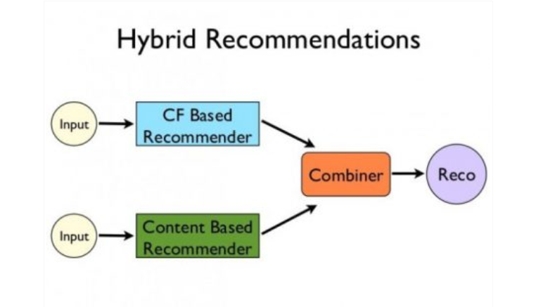

Hybrid Recommendation block diagram

Recent research has demonstrated that a hybrid approach, combining collaborative filtering and content-based filtering could be more effective in some cases. Hybrid approaches can be implemented in several ways, by making content-based and collaborative-based predictions separately and then combining them, by adding content-based capabilities to a collaborative-based approach (and vice versa), or by unifying the approaches into one model.

Netflix is a good example of the use of hybrid recommender systems. The website makes recommendations by comparing the watching and searching habits of similar users (i.e. collaborative filtering) as well as by offering movies that share characteristics with films that a user has rated highly (content-based filtering).

## TMDb — The Movie Database

[The Movie Database (TMDb)](https://www.themoviedb.org/) is a community built movie and TV database which has extensive data about movies and TV Shows. Here are the stats —



Source: <https://www.themoviedb.org/about>

For simplicity and easy computation, I have used a subset of this huge dataset which is the TMDb 5000 dataset. It has information about 5000 movies, split into 2 CSV files.

* **tmdb_5000_movies.csv:**Contains information like the **score, title, date_of_release, genres, etc.**
* **tmdb_5000_credits.csv:**Contains information of the **cast and crew** for each movie.

**Building the recommendation system**

## Step 1 — Import the dataset

So the first and foremost step is to Import the required Python libraries like Pandas, Numpy, Seaborn, and Matplotlib. Then import the CSV files using read_csv() function predefined in Pandas.

Numpy – Used for multi-dimensional arrays

Pandas – Used for reading the dataset

movies = pd.read_csv('../input/tmdb-movie-metadata/tmdb_5000_movies.csv')

credits = pd.read_csv('../input/tmdb-movie-metadata/tmdb_5000_credits.csv')

## Step 2 — Data Exploration and Cleaning

We will initially use the **head()**, **describe()** function to view the values and structure of the dataset, and then move ahead with cleaning the data.

movies.head()

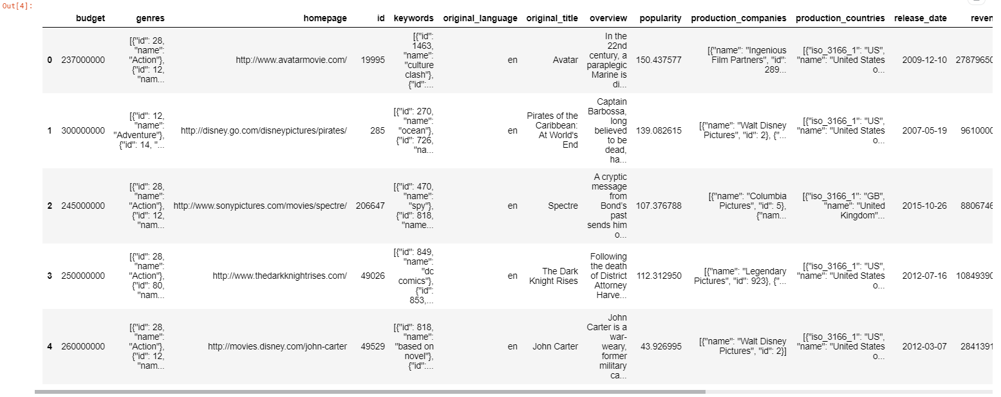

movies.describe()

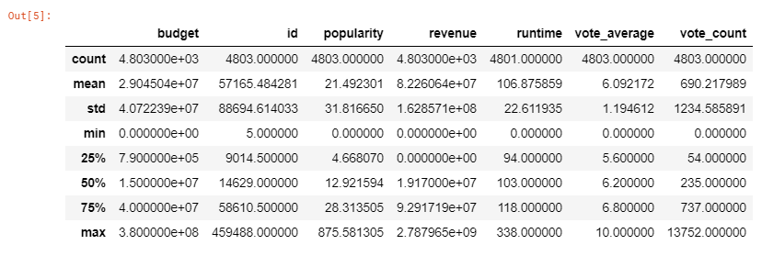

Similarly, we can get an intuition of the credits dataframe and get an output as follows —

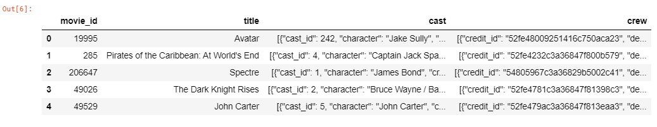

Checking the dataset, we can see that genres, keywords, production_companies, production_countries, spoken_languages are in the JSON format. Similarly in the other CSV file, cast and crew are in the JSON format. Now let’s convert these columns into a format that can be easily read and interpreted. We will convert them into strings and later convert them into lists for easier interpretation.

The JSON format is like a dictionary (key: value) pair embedded in a string. Generally, parsing the data is computationally expensive and time-consuming. Luckily this dataset doesn’t have that complicated structure. A basic similarity between the columns is that they have a name key, which contains the values that we need to collect. The easiest way to do so parse through the JSON and check for the name key on each row. Once the name key is found, store the value of it into a list and replace the JSON with the list.

But we cannot directly parse this JSON as it has to be decoded first. For this, we use the ***json.loads()*** method, which decodes it into a list. We can then parse through this list to find the desired values. Let’s look at the proper syntax below.

# changing the genres column from json to string

movies['genres'] = movies['genres'].apply(json.loads)

for index,i in zip(movies.index,movies['genres']):

list1 = []

for j in range(len(i)):

list1.append((i[j]['name'])) # the key 'name' contains the name of the genre

movies.loc[index,'genres'] = str(list1)

In a similar fashion, we will convert the JSON to a list of strings for the columns: keywords, production_companies, cast, and crew. We will check if all the required JSON columns have been converted to strings using ***movies.iloc[index]***

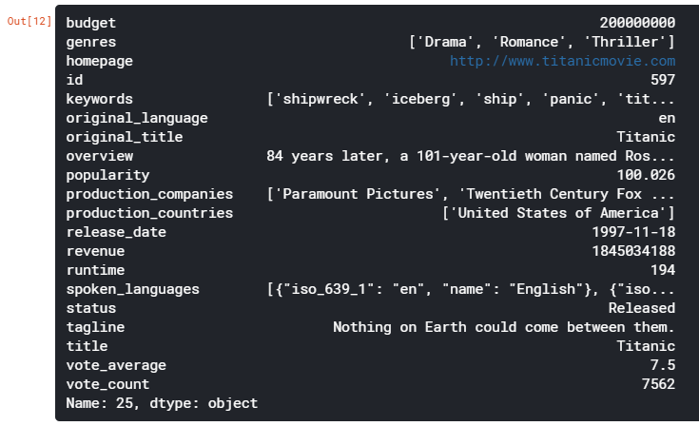

Fig. Details of the movie at index 25

## Step 3 — Merge the 2 CSV files

Now we will merge the movies and credits dataframes and select the columns which are required and have a unified **movies** dataframe to work on.

movies = movies.merge(credits, left_on='id', right_on='movie_id', how='left')

movies = movies[['id', 'original_title', 'genres', 'cast', 'vote_average', 'director', 'keywords']]

We can check the size and attributes of movies like this —

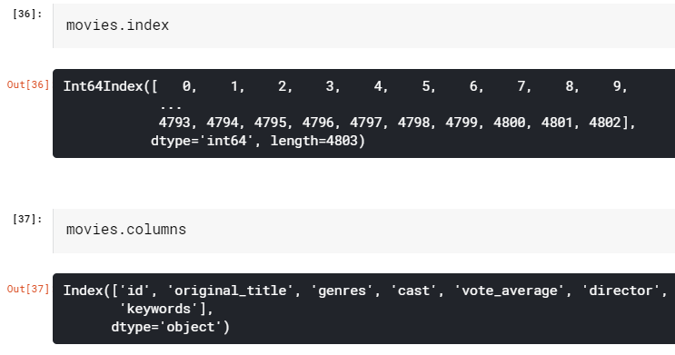

## Step 4 — Working with the Genres column

The next step is that we will clean the genre column to find the genre_list

movies['genres'] = movies['genres'].str.strip('[]').str.replace(' ','').str.replace("'",'')

movies['genres'] = movies['genres'].str.split(',')

Let’s plot the genres in terms of their occurrence to get an insight into movie genres in terms of popularity.

plt.subplots(figsize=(12,10))

list1 = []

for i in movies['genres']:

list1.extend(i)

ax = pd.Series(list1).value_counts()[:10].sort_values(ascending=True).plot.barh(width=0.9,color=sns.color_palette('hls',10))

for i, v in enumerate(pd.Series(list1).value_counts()[:10].sort_values(ascending=True).values):

ax.text(.8, i, v,fontsize=12,color='white',weight='bold')

plt.title('Top Genres')

plt.show()

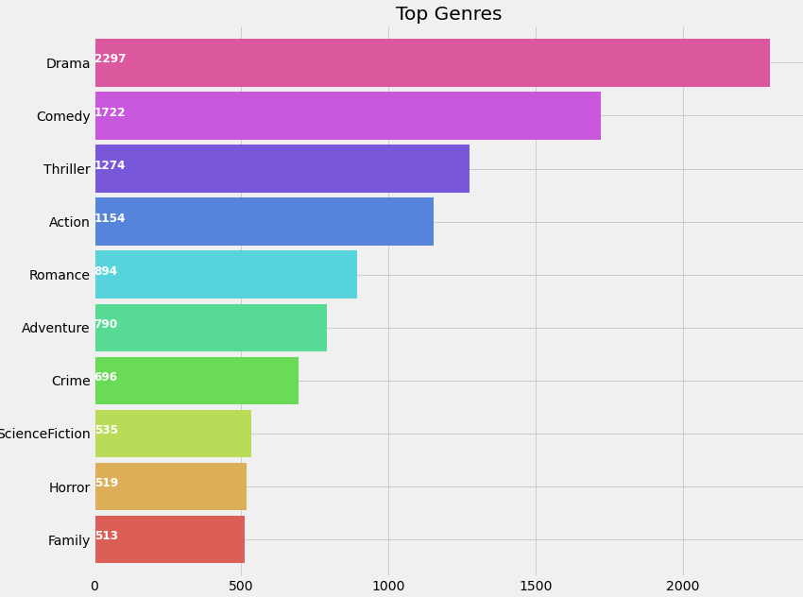

In this set of data drama appears to be the most popular genre followed by Comedy

Now let’s generate a list ‘genreList’ with all possible unique genres mentioned in the dataset.

genreList = []

for index, row in movies.iterrows():

genres = row["genres"]

for genre in genres:

if genre not in genreList:

genreList.append(genre)

genreList[:10] #now we have a list with unique genres

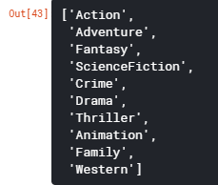

Fig. Unique genres

#### ****One Hot Encoding for multiple labels****

‘genreList’ will now hold all the genres. But how do we come to know about the genres each movie falls into. Now some movies will be ‘Action’, some will be ‘Action, Adventure’, etc. We need to classify the movies according to their genres.

Let’s create a new column in the dataframe that will hold the binary values whether a genre is present or not in it. First, let’s create a method that will return back a list of binary values for the genres of each movie. The ‘genreList’ will be useful now to compare against the values.

Let’s say for example we have 20 unique genres in the list. Thus the below function will return a list with 20 elements, which will be either 0 or 1. Now for example we have a Movie which has genre = ‘Action’, then the new column will hold [1,0,0,0,0,0,0,0,0,0,0,0,0,0,0,0,0,0,0,0].

Similarly for ‘Action, Adventure’ we will have, [1,1,0,0,0,0,0,0,0,0,0,0,0,0,0,0,0,0,0,0]. Converting the genres into such a list of binary values will help in easily classifying the movies by their genres.

def binary(genre_list):

binaryList = []

for genre in genreList:

if genre in genre_list:

binaryList.append(1)

else:

binaryList.append(0)

return binaryList

Applying the **binary()** function to the ‘genres’ column to get ‘genre_list’

We will follow the same notations for other features like the cast, director, and the keywords.

movies['genres_bin'] = movies['genres'].apply(lambda x: binary(x))

movies['genres_bin'].head()

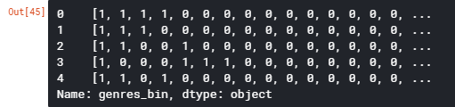

Fig. genre_list columns values

## ****Step 5 — Working with the Cast column****

Let’s plot a graph of Actors with Highest Appearances

plt.subplots(figsize=(12,10))

list1=[]

for i in movies['cast']:

list1.extend(i)

ax=pd.Series(list1).value_counts()[:15].sort_values(ascending=True).plot.barh(width=0.9,color=sns.color_palette('muted',40))

for i, v in enumerate(pd.Series(list1).value_counts()[:15].sort_values(ascending=True).values):

ax.text(.8, i, v,fontsize=10,color='white',weight='bold')

plt.title('Actors with highest appearance')

plt.show()

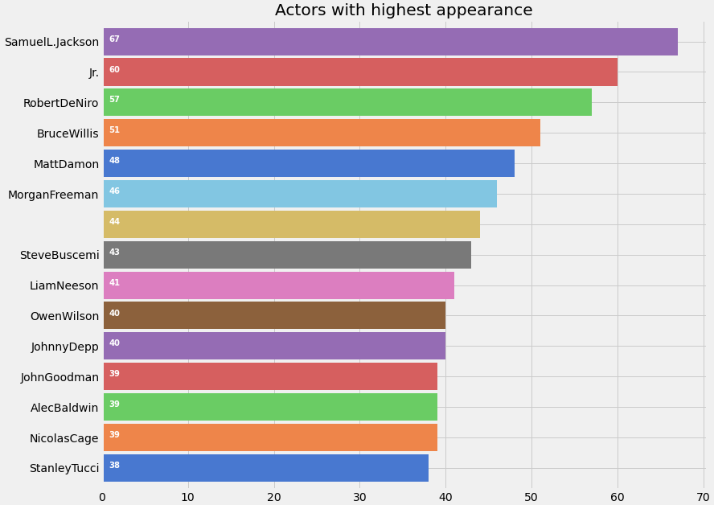

When I initially created the list of all the cast, it had around 50k unique values, as many movies have entries for about 15–20 actors. But do we need all of them? The answer is No. We just need the actors who have the highest contribution to the movie. For eg: The Dark Knight franchise has many actors involved in the movie. But we will select only the main actors like Christian Bale, Micheal Caine, Heath Ledger. I have selected the main 4 actors from each movie.

One question that may arise in your mind is how do you determine the importance of the actor in the movie. Luckily, the sequence of the actors in the JSON format is according to the actor’s contribution to the movie.

Let’s see how we do that and create a column ‘cast_bin’

for i,j in zip(movies['cast'],movies.index):

list2 = []

list2 = i[:4]

movies.loc[j,'cast'] = str(list2)

movies['cast'] = movies['cast'].str.strip('[]').str.replace(' ','').str.replace("'",'')

movies['cast'] = movies['cast'].str.split(',')

for i,j in zip(movies['cast'],movies.index):

list2 = []

list2 = i

list2.sort()

movies.loc[j,'cast'] = str(list2)

movies['cast']=movies['cast'].str.strip('[]').str.replace(' ','').str.replace("'",'')castList = []

for index, row in movies.iterrows():

cast = row["cast"]

for i in cast:

if i not in castList:

castList.append(i)movies[‘cast_bin’] = movies[‘cast’].apply(lambda x: binary(x))

movies[‘cast_bin’].head()

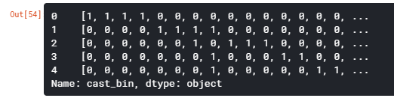

cast_bin column values

## Step 6 — Working with the Directors column

Let’s plot Directors with maximum movies

def xstr(s):

if s is None:

return ''

return str(s)

movies['director'] = movies['director'].apply(xstr)plt.subplots(figsize=(12,10))

ax = movies[movies['director']!=''].director.value_counts()[:10].sort_values(ascending=True).plot.barh(width=0.9,color=sns.color_palette('muted',40))

for i, v in enumerate(movies[movies['director']!=''].director.value_counts()[:10].sort_values(ascending=True).values):

ax.text(.5, i, v,fontsize=12,color='white',weight='bold')

plt.title('Directors with highest movies')

plt.show()

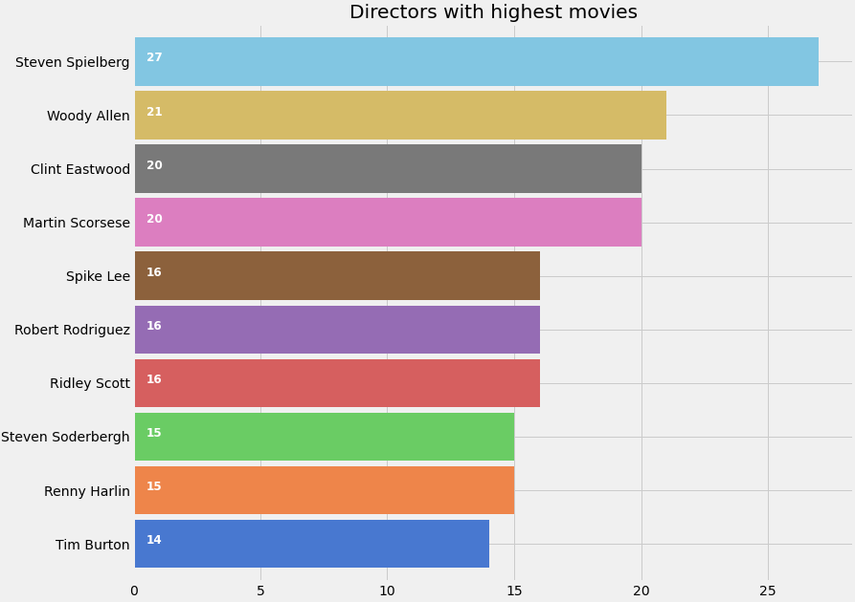

We create a new column ‘**director_bin**’ as we have done earlier

directorList=[]

for i in movies['director']:

if i not in directorList:

directorList.append(i)movies['director_bin'] = movies['director'].apply(lambda x: binary(x))

movies.head()

So finally, after all this work we get the movies dataset as follows

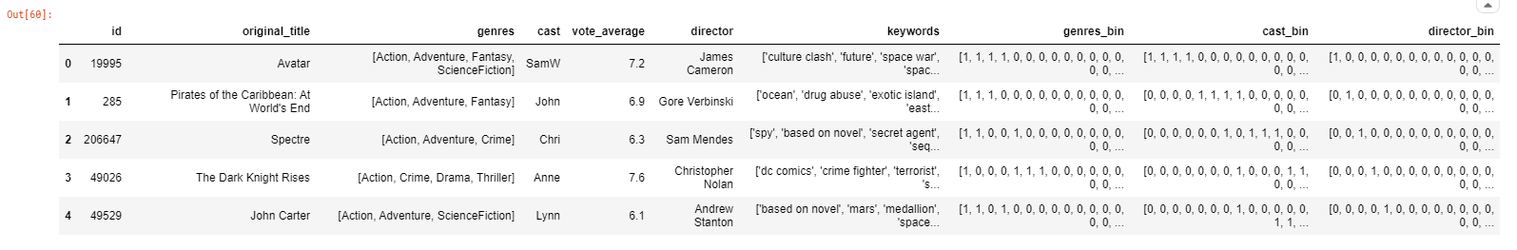

Fig. Movies dataframe after One Hot Encoding

## Step 7 — Working with the Keywords column

The keywords or tags contain a lot of information about the movie, and it is a key feature in finding similar movies. For eg: Movies like “Avengers” and “Ant-man” may have common keywords like superheroes or Marvel.

For analyzing keywords, we will try something different and plot a word cloud to get a better intuition:

from wordcloud import WordCloud, STOPWORDS

import nltk

from nltk.corpus import stopwordsplt.subplots(figsize=(12,12))

stop_words = set(stopwords.words('english'))

stop_words.update(',',';','!','?','.','(',')','$','#','+',':','...',' ','')words=movies['keywords'].dropna().apply(nltk.word_tokenize)

word=[]

for i in words:

word.extend(i)

word=pd.Series(word)

word=([i for i in word.str.lower() if i not in stop_words])

wc = WordCloud(background_color="black", max_words=2000, stopwords=STOPWORDS, max_font_size= 60,width=1000,height=1000)

wc.generate(" ".join(word))

plt.imshow(wc)

plt.axis('off')

fig=plt.gcf()

fig.set_size_inches(10,10)

plt.show()



    Above is a word cloud showing the major keywords or tags used for describing the movies (this is a random picture taken from google)

We find ‘**words_bin**’ from Keywords as follows —

movies['keywords'] = movies['keywords'].str.strip('[]').str.replace(' ','').str.replace("'",'').str.replace('"','')

movies['keywords'] = movies['keywords'].str.split(',')

for i,j in zip(movies['keywords'],movies.index):

list2 = []

list2 = i

movies.loc[j,'keywords'] = str(list2)

movies['keywords'] = movies['keywords'].str.strip('[]').str.replace(' ','').str.replace("'",'')

movies['keywords'] = movies['keywords'].str.split(',')

for i,j in zip(movies['keywords'],movies.index):

list2 = []

list2 = i

list2.sort()

movies.loc[j,'keywords'] = str(list2)

movies['keywords'] = movies['keywords'].str.strip('[]').str.replace(' ','').str.replace("'",'')

movies['keywords'] = movies['keywords'].str.split(',')words_list = []

for index, row in movies.iterrows():

genres = row["keywords"]

for genre in genres:

if genre not in words_list:

words_list.append(genre)movies['words_bin'] = movies['keywords'].apply(lambda x: binary(x))

movies = movies[(movies['vote_average']!=0)] #removing the movies with 0 score and without drector names

movies = movies[movies['director']!='']

## Step 8 — Similarity between movies

We will be using **Cosine Similarity** for finding the similarity between 2 movies. How does cosine similarity work? We take two vectors and find the similarity between them

Let’s say we have 2 vectors. If the vectors are close to parallel, i.e. angle between the vectors is 0, then we can say that both of them are “similar”, as cos(0)=1. Whereas if the vectors are orthogonal, then we can say that they are independent or NOT “similar”, as cos(90)=0.

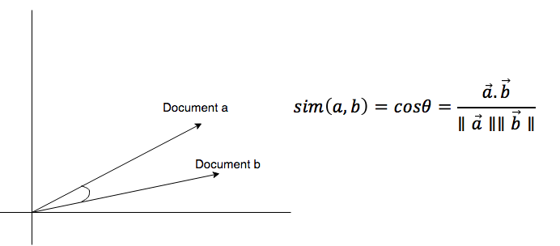

Cosine similarity

Below I have defined a function Similarity, which will check the similarity between the movies.

from scipy import spatialdef Similarity(movieId1, movieId2):

a = movies.iloc[movieId1]

b = movies.iloc[movieId2]

genresA = a['genres_bin']

genresB = b['genres_bin']

genreDistance = spatial.distance.cosine(genresA, genresB)

scoreA = a['cast_bin']

scoreB = b['cast_bin']

scoreDistance = spatial.distance.cosine(scoreA, scoreB)

directA = a['director_bin']

directB = b['director_bin']

directDistance = spatial.distance.cosine(directA, directB)

wordsA = a['words_bin']

wordsB = b['words_bin']

wordsDistance = spatial.distance.cosine(directA, directB)

return genreDistance + directDistance + scoreDistance + wordsDistance

Let’s check the Similarity between 2 random movies

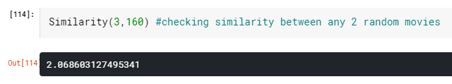

We see that the distance is about 2.068, which is high. The more the distance, the less similar the movies are. Let’s see what these random movies actually were.

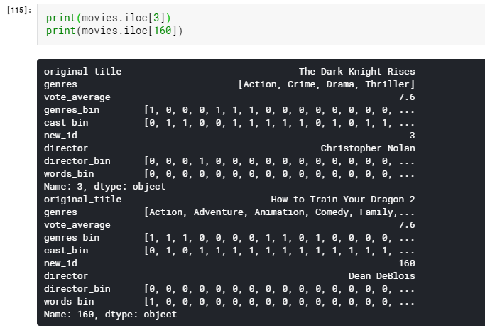

It is evident that The Dark Knight Rises and How to train your Dragon 2 are very different movies. Thus the distance is huge.

## Step 9 — Score Predictor (the final step!)

So now when we have everything in place, we will now build the score predictor. The main function working under the hood will be the **Similarity()** function, which will calculate the similarity between movies, and will find 10 most similar movies. These 10 movies will help in predicting the score for our desired movie. We will take the average of the scores of similar movies and find the score for the desired movie.

Now the similarity between the movies will depend on our newly created columns containing binary lists. We know that features like the director or the cast will play a very important role in the movie’s success. We always assume that movies from David Fincher or Chris Nolan will fare very well. Also if they work with their favorite actors, who always fetch them success and also work on their favorite genres, then the chances of success are even higher. Using these phenomena, let’s try building our score predictor.

import operatordef predict_score():

name = input('Enter a movie title: ')

new_movie = movies[movies['original_title'].str.contains(name)].iloc[0].to_frame().T

print('Selected Movie: ',new_movie.original_title.values[0])

def getNeighbors(baseMovie, K):

distances = []

for index, movie in movies.iterrows():

if movie['new_id'] != baseMovie['new_id'].values[0]:

dist = Similarity(baseMovie['new_id'].values[0], movie['new_id'])

distances.append((movie['new_id'], dist))

distances.sort(key=operator.itemgetter(1))

neighbors = []

for x in range(K):

neighbors.append(distances[x])

return neighbors

K = 10

avgRating = 0

neighbors = getNeighbors(new_movie, K)print('\nRecommended Movies: \n')

for neighbor in neighbors:

avgRating = avgRating+movies.iloc[neighbor[0]][2]

print( movies.iloc[neighbor[0]][0]+" | Genres: "+str(movies.iloc[neighbor[0]][1]).strip('[]').replace(' ','')+" | Rating: "+str(movies.iloc[neighbor[0]][2]))

print('\n')

avgRating = avgRating/K

print('The predicted rating for %s is: %f' %(new_movie['original_title'].values[0],avgRating))

print('The actual rating for %s is %f' %(new_movie['original_title'].values[0],new_movie['vote_average']))

Now simply just run the function as follows and enter the movie you like to find 10 similar movies and it’s predicted ratings

predict_score()

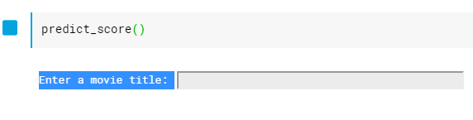

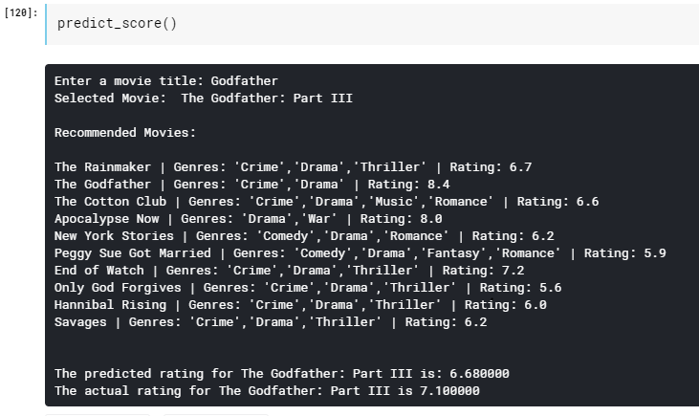

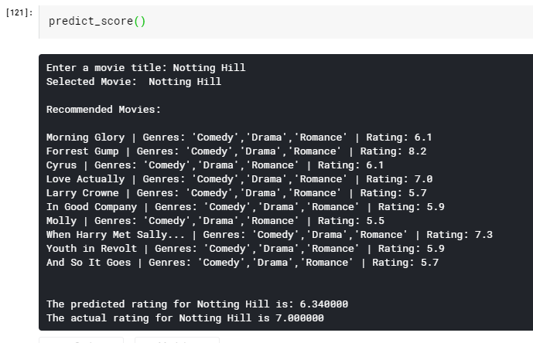

Recommendation System using K-Nearest Neighbors: Predict Scores

Thus we have completed the Movie Recommendation System implementation using the K-Nearest Neighbors algorithm.

**Conclusion**

We built a recommendation system using hybrid filtering, I learnt the need and importance of these recommender systems, types of system being implemented, how the dataset used is being implemented, cosine similarity, keyword availability and a whole lot of other principles.

Since recommendation systems are becoming increasingly important in today’s hectic world. People are always in the lookout for products/services that are best suited for them. Therefore, the recommendation systems are important as they help them make the right choices, without having to expend their cognitive resources.

ommendation System using K-Nearest Neighbors – Cosine Similarity Recommendation System using K-Nearest Neighbors – Cosine Similarity

**Bibliography**

* Movie recommender system – Krish Naik(Youtube)
* Building a recommendation system – Code Heeroku(Youtube)
* <https://towardsdatascience.com/how-to-build-a-movie-recommendation-system-67e321339109>
* <https://www.analyticsvidhya.com/blog/2020/08/recommendation-system-k-nearest-neighbors/>
* Kaggle.com
* <https://www.researchgate.net/publication/341941415_Movie_Recommendation_System_PYTHON_PROJECT_REPORT>